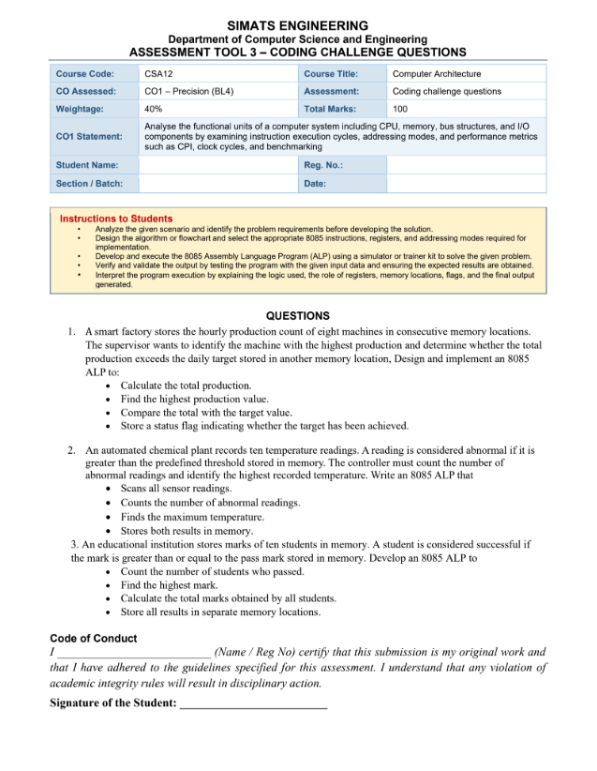 COMPUTER ARCHITECTURE -CSA 1214
K.B.Tharunika(192525276)
Question 1: A smart factory stores the hourly production count of eight machines in consecutive memory locations. The supervisor wants to identify the machine with the highest production and determine whether the total production exceeds the daily target stored in another memory location, Design and implement an 8085
ALP to: • Calculate the total production. • Find the highest production value. • Compare the total with the target value. • Store a status flag indicating whether the target has been achieved.
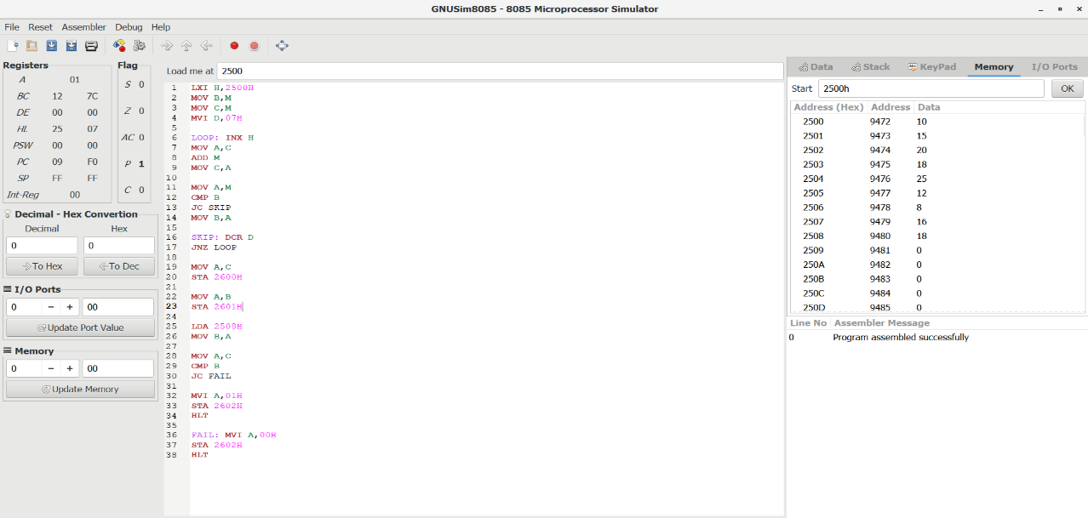

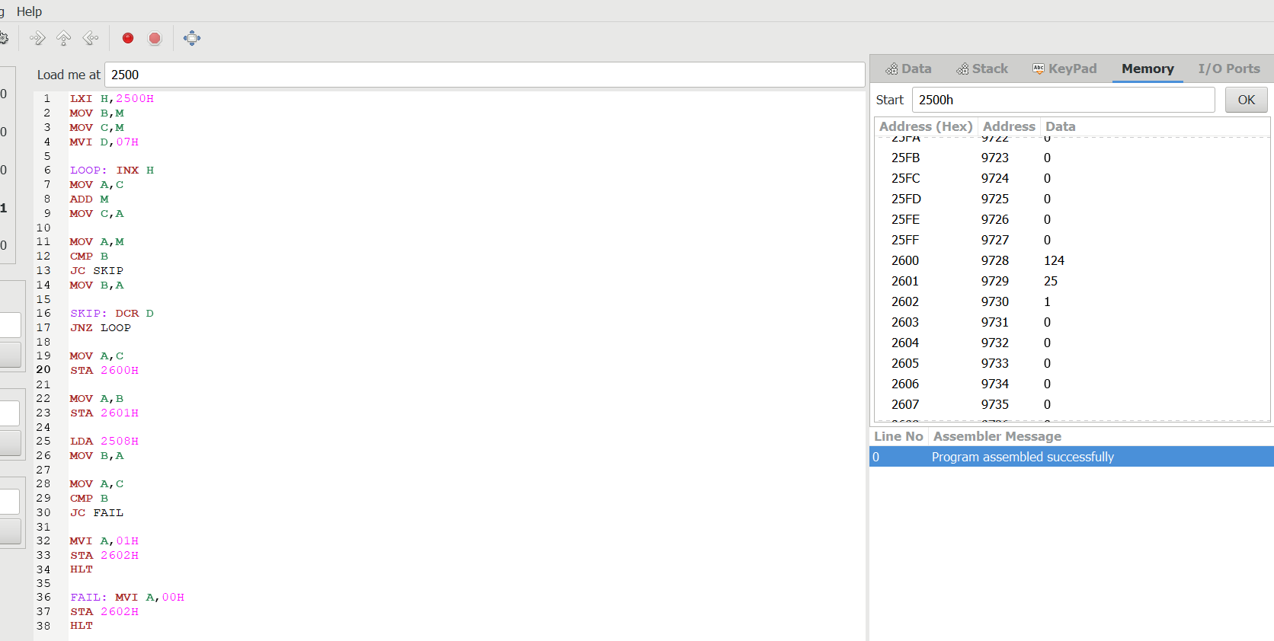
Question 2: An automated chemical plant records ten temperature readings. A reading is considered abnormal if it isgreater than the predefined threshold stored in memory. The controller must count the number of abnormal readings and identify the highest recorded temperature. Write an 8085 ALP that • Scans all sensor readings.
• Counts the number of abnormal readings. • Finds the maximum temperature.• Stores both results in memory.
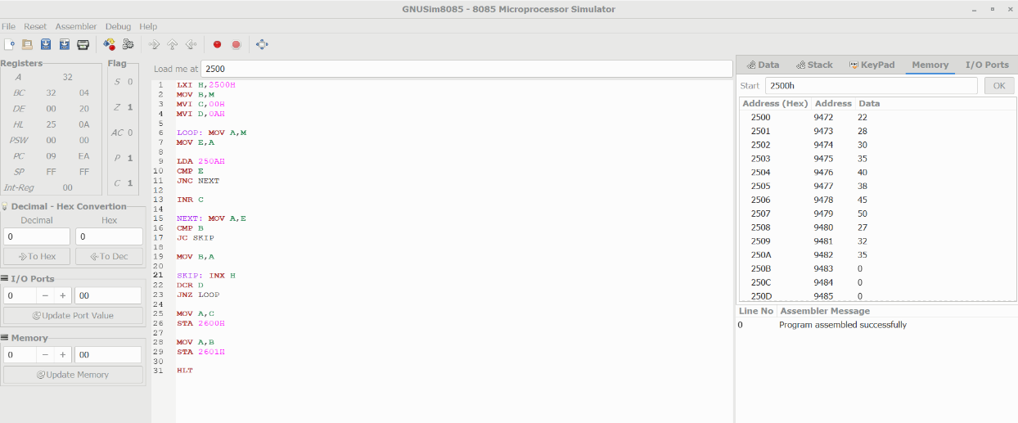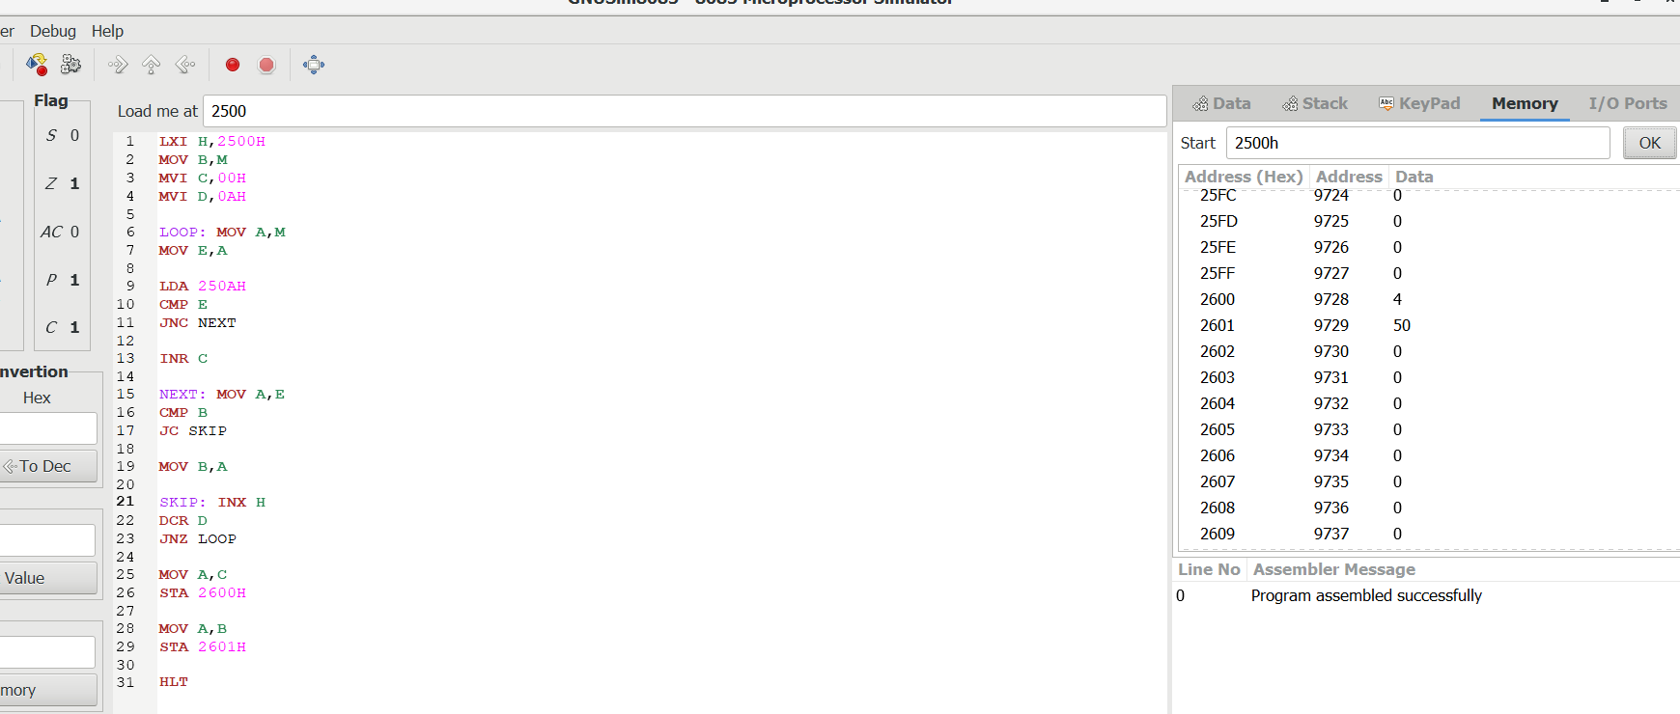

Question 3: An educational institution stores marks of ten students in memory. A student is considered successful if the mark is greater than or equal to the pass mark stored in memory. Develop an 8085 ALP to
• Count the number of students who passed. • Find the highest mark.
• Calculate the total marks obtained by all students. • Store all results in separate memory locations.

